**Exp No - 6 Applying DML commands on Road Way Travels Tables. Data Manipulation Command**

**• Insert**

**• Update**

**• Delete**

**• Select**

**insert into employees values(100, '2020-01-01', 'john', 'elton', 'M', '2021-04-20');**

**alter table employees add temp numeric;**

**update employees set temp = 10 where emp_id = 100;**

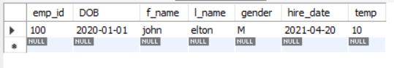

**insert into employees value(102, '2021-03-23', 'G', 'P', 'M', '2021-05-05',12);**

**alter table employees drop temp;**

**insert into employees value(101, '2021-01-22', 'P', 'F', 'F', '1999-05-05');**

**insert into employees value(103, '2021-12-02', 'A', 'B', 'F', '1979-12-29');**

**insert into employees value(104, '2017-6-23', 'B', 'M', 'M', '1899-01-17');**

**insert into employees value(105, '2019-12-11', 'R', 'A', 'M', '2021-11-01');**

**select * from employees;**

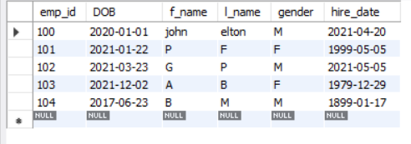

**select distinct gender from employees;**

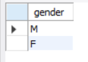

**select count(distinct gender) from employees;**

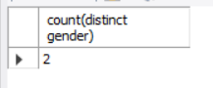

**select DOB from employees where emp_id = 100;**

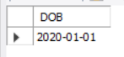

**select * from employees where emp_id > 101;**

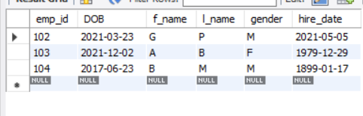

**update employees set f_name = 'Alfred', l_name = 'Schmidt' where emp_id = 103;**

**insert into employees values(107, '2017-06-23', 'S', 'R', 'F', '1899-01-17');**

**delete from employees where emp_id = 107;**

**select * from employees;**

